

………………………………………………………………………………………………………………………………………………………………....

**Software Maintenance**

**Diamond Hunter**

**(COURSE WORK 2)**

**Prepared by: Wael Aldroubi**

**Metric Number: 023676**

**Course: Bachelor of computer science**

**Date: 10/11/2016**

**Teacher Name: Mr. Hani**

………………………………………………………………………………………………………………………………………………………………....

**Table of content:**

|  |  |
| --- | --- |
| **Page** | **Subject** |
| **0** | **Cover Page** |
| **1** | **Table of content and clarification** |
| **2** | **Code explanation** |
| **3** | **My User Interface** |

**Clarification:**

**This Homework has been done by Wael Aldroubi, Student at International University Nottingham (Malaysia Campus), Matric Number 023676, Bachelor of computer science, Subject software maintenance, Teacher Mr. Hani**

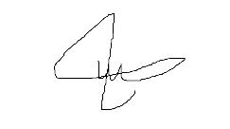**Name Signature Date**

**Wael Aldroubi 17/11/2016** ………………………………………………………………………………………………………………………………………………………………....

- My job as a project manager to develop and improve existing code, add functions and services.

- main task is after understanding Diamond hunter java game code and fixing the errors is to add some functions and services like viewing the map, view axe and boat positions (player earns), then changing their positions.

- During project time line, it was connected to GitHub, to track the changes and help team members to view the changes.

- I started by understanding how java swing works, and created four classes to read the map and it was successful to read it:   
1) engine: to set map width and height.  
2) Main: to control the screen and call the function, includes the main function.  
3) Drawpanel: responsible about the graphics, includes the graphics function.  
4) Tilelayer: to control the logic of calling the map and resources.

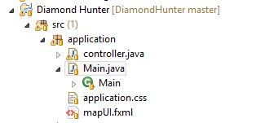- Then I created my JAVAFX class and it has:   
1) Main class to control the screen.  
2) Controller to connect the map viewer to javafx.  
3) I created the User Interface using scene builder and connected to javafx.

- Then I changed the four classes into one class called view.java in Tile map package, that class contained everything to call the map and it was connected to the javafx controller class. Then I connected it to a button (view diamond hunter map).

-Then I added another two buttons to view axe and boat and to play the game and created two more classes, one to view axe and boat and connect it to javafx class, then connected the game to one button.

-Then I started working on changing the coordinates of axe and boat, and during that I added a new button to view the diamonds.

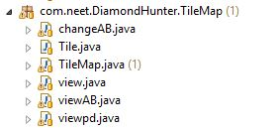1) View: to view game map  
2) viewab: to show axe and boat position  
3) viewpd: to show the diamonds  
4) changeab: to change the coordinates of axe and boat.

My User Interface:

